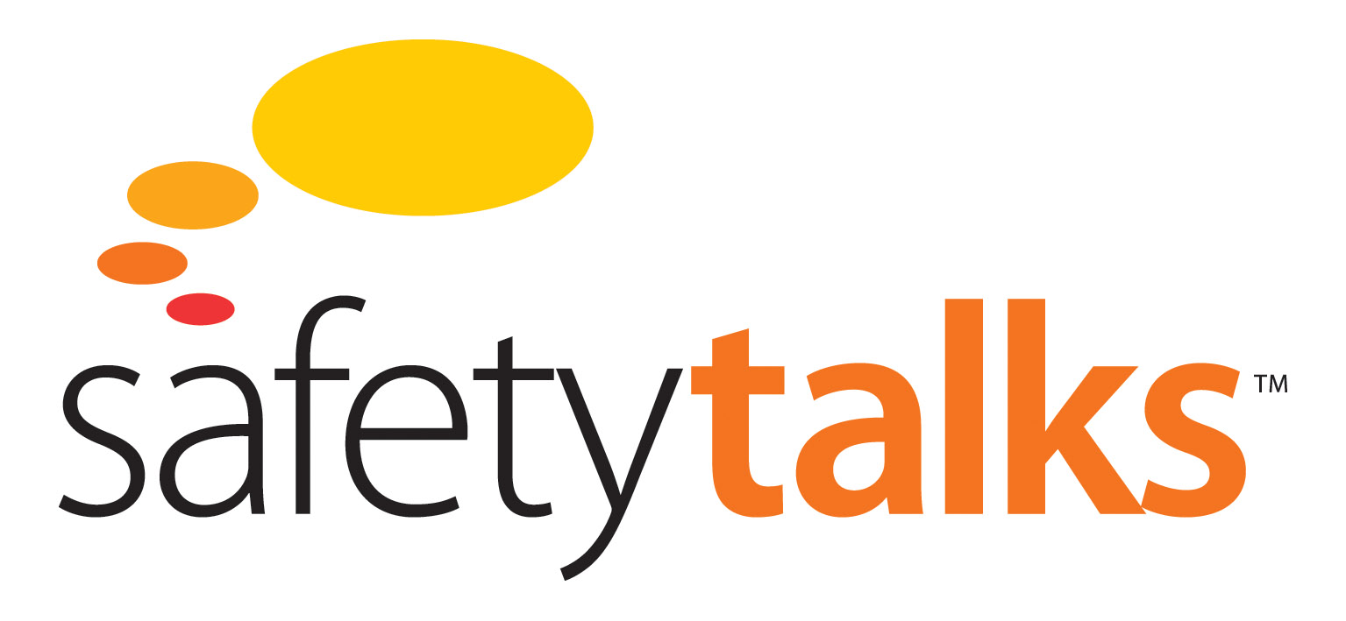

**Hazard Identification Module**

**Process Safety or Personal Safety**



Level 3, 75 King St, Sydney NSW 2000 Australia

t: +61 2 9279 4499 | f: +612 9279 4488

[info@futuremedia.com.au](mailto:info@futuremedia.com.au) | www.futuremedia.com.au

Safety Talks

Hazard Identification Module

Process Safety or Personal Safety Support Material

**Script**

Located 77 kilometres off the coast of Louisiana the huge floating drilling rig called the Deepwater Horizon had just completed drilling an ultra-deep well.

The bottom of the well was five and a half kilometres below sea level.

On the 20th of April 2010, the Macondo blowout in the Gulf of Mexico became the biggest oil spill in US history. Five million barrels of oil is the rough estimate, about twenty times the size of the Exxon Valdez oil spill in Alaska in 1989. Apart from being an environmental catastrophe, the Macondo was also a human disaster with 11 people killed.

The real causes of the accident are the human and organisational factors which we find at work in many other big accidents.

The best way to look at these causes is to start with the Swiss cheese model that we’ve all seen before. BP itself used this kind of analysis to explain the accident. It’s a very useful way of looking at accidents. In this program we will identify a few of the barriers that failed, but more importantly we will look at the human and organisational causes of these barrier failures.

The first failure was the cement job. The bottom of the well was supposed to be cemented in, to prevent oil and gas getting into the well, but the cement job was not effective. The crew carried out a procedure designed to test the integrity of the cement. The results of the test showed very clearly that the well was not properly sealed, that the cement job had failed, but the results were misinterpreted and the test was declared a success. Finally, the drillers were supposed to be monitoring the well to the very end of the process, but they failed to do so.

Why was there no focus on major hazard risk? The answer is to do with the distinction between process safety and personal safety. These are quite different types of safety that have to be managed quite differently. In the Gulf of Mexico, if you talked to people about safety, what they had in their mind was personal safety. They had no concept of process safety, no concept of major hazard risk. This is most dramatically illustrated in the story of the walk around which took place on the Deepwater Horizon. At the very time that the accident occurred, a group of four senior BP managers and Transocean managers – Transocean was the owner of the drilling rig – were doing a Management Visibility Tour. They were there for various reasons. They were there to make themselves visible, and to congratulate the rig on its remarkable injury-free performance. This rig had gone seven years without a lost-time injury. At the same time these managers were doing some informal auditing, but the kinds of hazards they were auditing were personal safety hazards such as slip, trip and fall hazards. One of the touring managers was aware of a trip hazard that existed on another rig and one of the questions in his mind was: does this hazard exist on the Deepwater Horizon? If so, has it been rectified? Or again, both companies were running a campaign at the time in relation to hand injuries. These managers were very focused on asking people about hand injuries and hand protection. **But there was no focus on major hazard safety.** The irony and tragedy of this is that while they were walking around the rig, the drillers were making a series of mistakes which led directly to the blowout. Had those executives been asking questions - what are you guys doing here? Tell us about what you’re doing. Tell us about how you are controlling your major hazard risks. Tell us about how you’re controlling your risk of blow out – they would have discovered that the rig crew was not controlling the risk of blowout. This would have forced the managers to put a stop to what was happening, and the accident probably would not have occurred. There was a real opportunity here to prevent the blowout occurring. But the touring managers did not take advantage of that opportunity **because their mindset was that safety meant personal safety.** So if we come back to our Macondo front line Macondo engineers, we have to say they were simply reflecting the beliefs and the behaviour that were being modelled for them by their senior managers.

**Suggested Discussion Questions and Answers**

Facilitator note:

This topic can create a very healthy debate within the participants

1. What does safety mean to us?

The response will be variable but the key issue in this instance is whether there is recognition of the distinction between personal and process safety

1. If there is recognition between personal and process safety, then ask the following:

How well do we manage process safety, could a ‘Macondo’ occur with us?

* Group discussion

1. If there is no recognition then ask the following:

What must be done if we have processes that we manage and control?

* Develop and implement a program to identify and manage the process risks