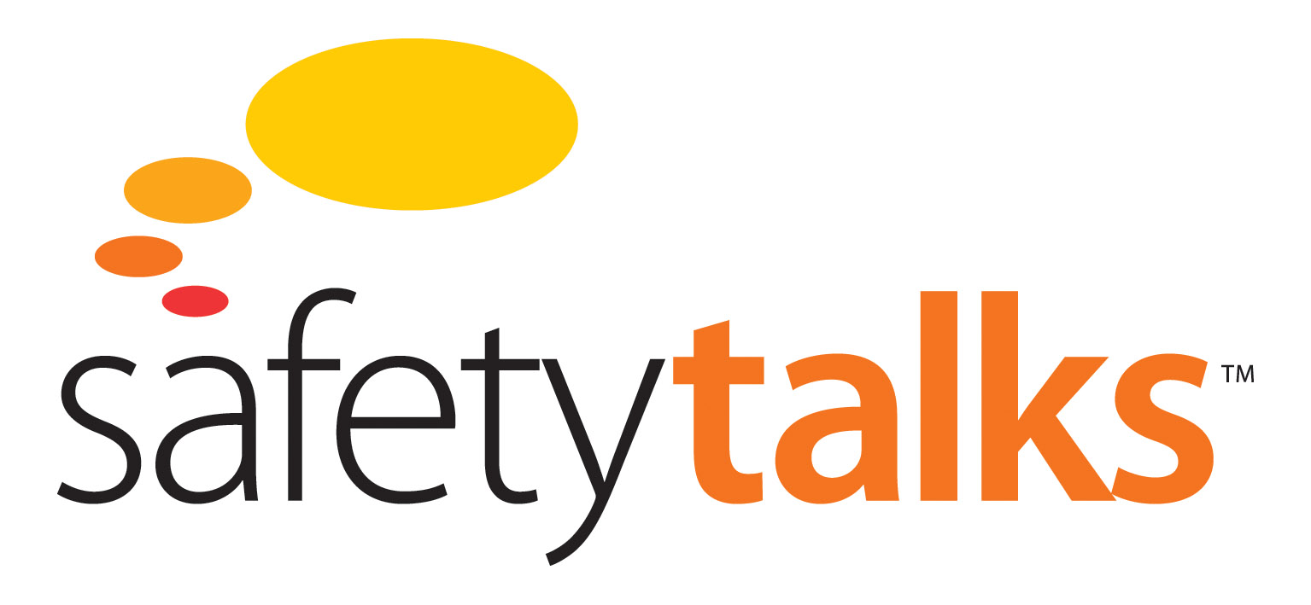

**Incident Reporting Systems Module**

**Key Points for Design**



Level 3, 75 King St, Sydney NSW 2000 Australia

t: +61 2 9279 4499 | f: +612 9279 4488

[info@futuremedia.com.au](mailto:info@futuremedia.com.au) | www.futuremedia.com.au

Safety Talks

Incident Reporting Systems Module

Key Points for Design Support Material

**Script**

The basic findings of almost all major accident research, is that prior to the accident there are always warning signs which, had they been responded to, would have averted the accident. But they weren’t, they were ignored. Mindful organisations are ones, which attend to these warning signs. It is this, which enables them to function with such high reliability.

Unfortunately there are many examples where organisations have failed to act on such warning signs. I want to give you a few examples of that just to make the point in a dramatic way. In 1996 the Gretley Coal Mine in NSW suffered an accident in which four men drowned.

They had been mining towards old abandoned flooded workings. And water was seeping out of the mine face, which should have been an indication that they may have been dangerously close to old flooded workings. They ignored those warnings and continued mining and broke through into the old workings and a vast amount of water came in and four miners were killed.

Another example concerns the explosion at the Esso Longford plant in Victoria that killed two men and cut off gas supplies to the city of Melbourne. The explosion occurred after operators had lost control of the process. A high-pressure vessel became dangerously, brittle with cold and shattered when operators tried to warm it up. A month before there was a similar cold temperature incident, which was a very clear warning that the process was out of control.

Fortunately there was no explosion on that occasion, but no further action was taken. Had that incident been responded to, had that warning been responded to, the accident a month later would not have occurred.

This is unfortunately a very typical story; there are always such warnings, which are missed for a variety of reasons. Mindful organisations don’t miss these signs.

So how can companies design a system, which will ensure that these warning signs are picked up properly and properly assessed? I believe the key to this is the reporting system. A ‘mindful organisation’ is one, which has a properly functioning reporting system, which will pick up these warning signs.

Now if you think about what’s wrong with some of the incident reporting systems in use today, one of the problems is already obvious. Most incident reporting systems focus very much on lost time injuries- and near misses, which have the capacity to generate a lost time injury.

Other things, which are not seen as having the potential to cause lost time injuries, for example process upsets in process plants, are not recorded, and not entered into incident reporting systems. So it’s important to design a reporting system, which is going to make sure that we are picking up that kind of warning information, which goes beyond lost time injury.

The other point is that quite a number of organisations have routine end of shift reporting systems which are indeed picking up the warning signs but nothing is being done with them.

This happened at the Gretley Mine where the end of shift reports by Safety Officers were picking up clear warning signs but nothing was being done with them.

A similar thing happened at the ESSO Longford Plant. The operators had completed end of shift logs and here are some of the comments from the Longford Reports. “This certain piece of equipment is very cold, could not find a reason why or how it warmed up.”

That’s a statement made by one of the operators, basically saying the system is out of control; something going wrong here; I don’t understand what is going wrong; and he writes a comment about it in his end of shift log. In retrospect that was a very, very significant warning, a precursor event to what subsequently happened. There were also much more direct kinds of comments in the logs, like “mayhem”. Now when operators are prepared to write that in their end of shift logs, when operators make those sorts of comments, they mean something. You don’t know what they mean but they mean something, and an organisation which is a ‘mindful organisation’ would be concerned to find out what these operators are trying to communicate.

A ‘mindful organisation’ would ask: “What are you trying to communicate”, because its concern is to pick up exactly that kind of information. Now those were paper end of shift reports and the problem with paper reports, especially ones filled out the end of every shift, is they are rapidly superseded by the next shift’s report and unless they’re responded to straight away they’re lost and gone forever. That’s typically what happens. It happened at Longford and it also happened at Gretley; it’s a very common story.

The warning signs were there but it was not picked up and responded to.

**Suggested Discussion Questions and Answers**

1. What types of incidents are recorded in the incident management system?

* Near Miss
* First Aid Injury
* Medical Treatment
* Lost time injury
* Disease
* Notifiable Injury/Illness
* Property Damage
* Minor Spill
* Major Spill
* Contamination
* Breakdowns
* Alarms
* Process Interruptions
* Process Variations
* Isolation failures

1. What training is provided on the incident management system to all levels in the organisation?

* Accountabilities/Responsibilities
* Procedures
* Warning sign recognition
* Investigation techniques
* Corrective action & Review
* Auditing

1. How is this training provided?

* Induction and Refresher training for all employees
* Investigation training and refresher training for all Supervisors and Managers
* ALL training to have competency assessment

1. How are incident reports perceived by employees in the organisation? i.e. value, layout, ease of completion, corrective actions etc.

* Group discussion