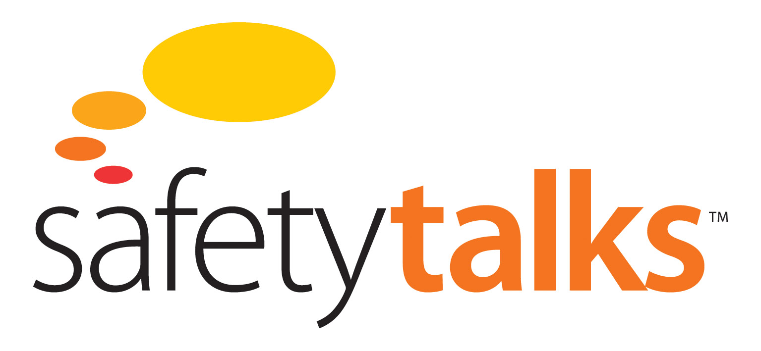

**Warning Signs – How They May be Ignored Module**

**It Can’t Happen Here**



Level 3, 75 King St, Sydney NSW 2000 Australia

t: +61 2 9279 4499 | f: +612 9279 4488

[info@futuremedia.com.au](mailto:info@futuremedia.com.au) | www.futuremedia.com.au

Safety Talks

Warning Signs – How They May be Ignored Module

It Can’t Happen Here Support Material

**Script**

In 1996 the Gretley Coal Mine in NSW suffered an accident in which four men drowned.

They had been mining towards old abandoned flooded workings. And water was seeping out of the mine face, which should have been an indication that they may have been dangerously close to old flooded workings. They ignored those warnings and continued mining and broke through into the old workings and a vast amount of water came in and four miners were killed.

My question is why are warnings ignored? And the basic answer is that there is a culture of denial in many organisations - A culture of denial, which is functioning to suppress the significance of warnings.

What do we mean by culture? Whenever the word culture is used, it’s important to understand just what the word refers to.

And what I am referring to when I speak of culture here is a series of beliefs. It’s a series of four beliefs, which enable people to dismiss the significance of warnings.

The first one is the belief that it can’t happen here.

If we go to the Gretley story again there was a belief that it can’t happen here. They would have said “We know about these hazards. We know about the dangers of flooded old workings. But we know it not a problem here because we have got it under control”.

How do we know we have this under control? Well we have some maps from New South Wales Mining Department and they indicate we are at least 100m away from those old workings. So we know that the water, which is seeping through the mine face cannot possibly be an indication of danger because we know we are not in danger.

And that unfortunately is a very common response, to a warning sign.

Ok. We know about the hazard. But we have a control in place. So we know we can dismiss that warning sign.

The point about warning signs is that they are always ambiguous. If they weren’t ambiguous, then we’d know how to respond to them. It’s their very ambiguity, which enables us to invoke multiple interpretations and to find an interpretation, which allows us to dismiss them.

Ok. So that’s the first belief – it can’t happen here.

**Suggested Discussion Questions and Answers**

1. Identify a specific hazard to which people could be exposed to on a frequent basis in the organisation but they ignore as ‘it can’t happen here’.

The context of the hazard is the focus i.e. a specific activity and associated hazard controls.

* For example: Corrosion of a pipeline (containing toxic material) noticed during a maintenance procedure, however other routines are known to deal with the corrosion. There is an assumption that the other routines deal with and manage the corrosion. And this may or may not be the case and, if it is the latter, then a toxic exposure event is likely.

1. Describe your reasons why you believe this is an ambiguous warning sign.

* An assumption is made that the ‘other’ routines will manage the corrosion