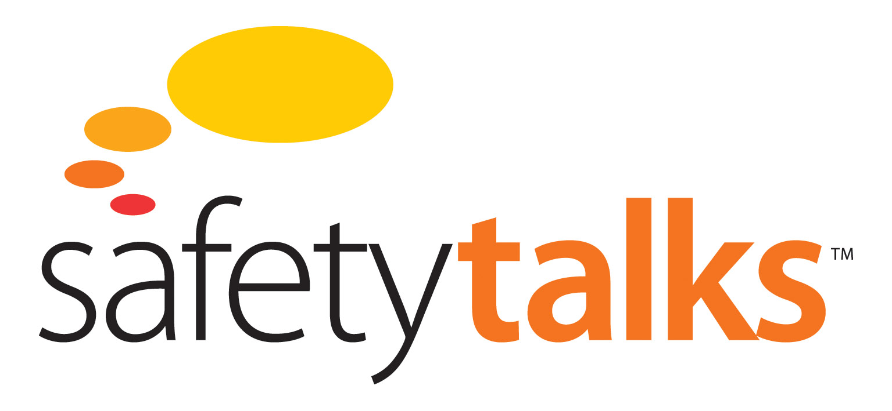

**Defence in Depth Module**

**Third Barrier: Well Integrity Test**



Level 3, 75 King St, Sydney NSW 2000 Australia

t: +61 2 9279 4499 | f: +612 9279 4488

[info@futuremedia.com.au](mailto:info@futuremedia.com.au) | www.futuremedia.com.au

Safety Talks

Defence in Depth Module

Third Barrier: Well Integrity Test Support Material

**Script**

Located 77 kilometres off the coast of Louisiana the huge floating drilling rig called the Deepwater Horizon had just completed drilling an ultra-deep well.

The bottom of the well was five and a half kilometres below sea level.

The Macondo blowout resulted in the death of eleven people, as well as an environmental catastrophe. This was the biggest oil spill in US history, twenty times the size of the Exxon Valdez oil spill in Alaska.

In this program I’ll be analysing the failure of the barriers or controls that should have prevented the Macondo blowout in the Gulf of Mexico. If any one of these barriers had worked as intended, the blowout would not have occurred. In examining why they all failed, I’ll be looking at how independent the barriers were, or rather, how interdependent they were. The barriers behaved like falling dominos. Once one fell, all the others followed. What happened at Macondo was the failure of the system of defence in depth. It wasn’t just one or two barriers that failed, but the whole system.

The first barrier was a physical barrier - a cement plug.

The second barrier was not even intended to be an independent barrier. It was something they were going to use if they thought the cement job might have failed. If there was some doubt about the cement job, they would use a cement evaluation tool to check on what the situation was.

The third barrier or control was a well integrity test.

The test involved reducing the pressure in the well to the point where, if the cement had not sealed the well properly, the oil and gas would begin to come in and begin to force its way up the well. If the cement was holding, then reducing the pressure would make no difference. Now the fact is that the well was not sealed, so when the pressure was reduced, oil and gas began to force its way up, and the pressure began to rise at the top of the well.

This indicated unequivocally that the cement job had failed. But the people doing the test did not draw this conclusion. Instead, they announced that the well had passed the integrity test.

How could they make such a serious mistake? They were subject to what social scientists call a ‘confirmation bias’. They should have been independently verifying that the well was secure. But they knew that the engineers had declared the well to be secure and so they saw their job as confirming this, and they kept trying until they found some evidence to support their belief. Here is what the presidential commission said: “The team conducting the test began with the assumption that the cement job had been successful and kept running tests and proposing explanations until they convinced themselves that their assumption was correct.” Their belief that the cement job had worked, that is, that the first barrier had worked, entirely undermined the third barrier. Barrier number three was useless precisely because they believed that barrier number one had worked. This is a horrifying illustration of the complete lack of independence of these defences.

**Suggested Discussion Questions and Answers**

1. Identify where confirmation bias could occur in your operation

* Group discussion
* Refer also to *Confirmation Bias* within the ‘Warning Signs – How they May be Ignored’ module

1. How can the issue of ‘confirmation bias’ be removed from jobs such as this?

* Ensure complete independence of the barriers (controls) – review design process for ensuring independence
* Develop an education program on ‘Confirmation Bias’ to bring together the personnel impacted by this issue
  + Identify key personnel (employees and contractors)
  + Identify ‘critical jobs’ that can be subject to confirmation bias
  + Develop a workshop to demonstrate the power of confirmation bias (use Macondo as a case study)
  + Develop an Action plan from the workshop
  + Include ‘Confirmation Bias’ in employee/contractor induction/training program
* Strict adherence to the planned steps
* Involvement of key supervisory/management staff
* Assign accountability